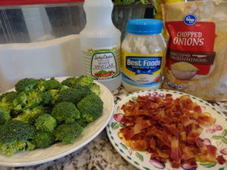
Deb’s Broccoli Salad
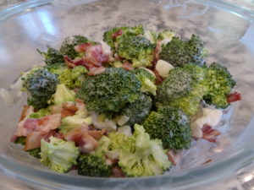
The recipe calls for 8 slices of bacon, cooked crisp. In a pinch I've used the Hormel fully cooked bacon. Since those slices aren't super thick, I use ten instead of the eight the recipe calls for.

It only takes a few minutes to put together; the longest part is cutting the broccoli florets. First I cook, cool and cut the bacon, then I cut the broccoli as the bacon cools. Combine the bacon with chopped broccoli in your serving bowl.
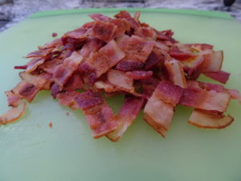
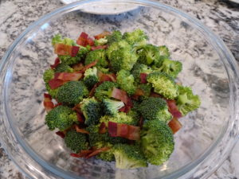

Next, stir the onions, mayonnaise, sugar and vinegar together in a separate bowl until the sugar is dissolved.
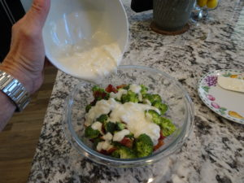
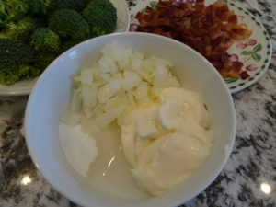

Pour the dressing on the bacon and broccoli mixture and toss it all together. I like to let it chill for a couple hours and give it a good stir before serving. (You could add some cashews for extra crunch.) Enjoy!
Ingredients
- 1/2 cup frozen chopped onions
- 3/4 cup mayonnaise (can use light)
- 1/4 cup sugar
- 2 Tablespoons vinegar
- 4 cups fresh broccoli florets (one bunch)
- 8 slices crispy cooked thick bacon.

